Power supplies & Special semi conductor devices

The basic purpose of a power supply is to provide one or more fixed voltages to the
working circuit, with sufficient current-handling capacity to maintain the operating conditions of the circuit.

THE BASIC POWER SUPPLY
Figure given below shows the block diagram of a basic power supply. Most
power supplies are made up of four basic sections: a transformer, a rectifier, a
filter, and a regulator.
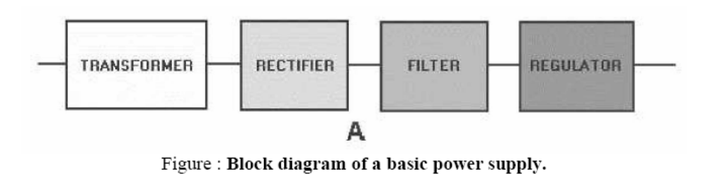
The first section is the transformer. The transformer steps up or steps down the input line voltage and isolates the power supply from the power line. The rectifier section converts the alternating current input signal to a pulsating direct current. Pulsating dc
is not desirable. For this reason a filter section is used to convert pulsating dc to a purer, more desirable form of dc voltage. The final section, the regulator, does just what the name implies. It maintains the output of the power supply at a constant level in spite of large changes in load current or input line voltages.

TRANSFORMER
In general, the ac line voltage present in your house wiring is not suitable for electronic
circuits. Most circuits require a considerably lower voltage, while a few require higher voltages.The transformer serves to convert the ac line voltage to a voltage level more appropriate to the needs of the circuit to be powered. At the same time, the transformer provides electrical isolation between the ac line and the circuit being powered, which is an important safety consideration.
However, a line transformer is generally large and heavy, and is rather expensive. Therefore, some power supplies (notably for PCs) are deliberately designed to operate directly from the ac line without a line transformer. The output of the transformer is still an ac voltage, but now of an appropriate magnitude for the circuit to be powered.
RECTIFIER
The next step is to force current to flow in one direction only, preventing the alternations
that occur in the transformer and the ac line. This process is known as rectification, and the circuit that accomplishes the task is the rectifier. There are many different rectifier
configurations that may be used according to the requirements of the circuit. The output of the rectifier is a pulsating dc, which still has some of the variations from the ac line and transformer.
The purpose of the rectifier section is to convert the incoming ac from a transformer or
other ac power source to some form of pulsating dc. That is, it takes current that flows alternately in both directions as shown in the first figure to the right, and modifies it so that the output current flows only in one direction, as shown in the second and third figures below. The circuit required to do this may be nothing more than a single diode, or it may be considerably more complex. However, all rectifier circuits may be classified into one of two categories, as follows:
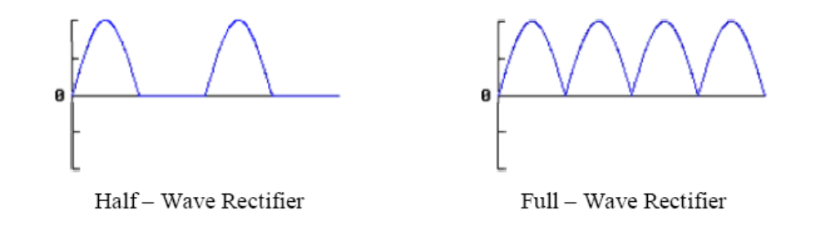
Half-Wave Rectifiers. An easy way to convert ac to pulsating dc is to simply allow half of the ac cycle to pass, while blocking current to prevent it from flowing during the other half cycle. The figure to the right shows the resulting output. Such circuits are known as half-wave rectifiers because they only work on half of the incoming ac wave.

Full-Wave Rectifiers. The more common approach is to manipulate the incoming ac wave so that both halves are used to cause output current to flow in the same direction. The resulting waveform is shown to the right. Because these circuits operate on the entire incoming ac wave, they are known as full-wave rectifiers.

FILTER
The pulsating dc from the rectifier is generally still not suitable to power the actual load
circuit. The pulsations typically vary from 0 volts to the peak output voltage of the transformer. Therefore, we insert a circuit to store energy during each voltage peak, and then release it to the load when the rectifier output voltage drops. This circuit is called a filter, and its job is to reduce the pulses from the rectifier to a much smaller ripple voltage. No filter configuration can be absolutely perfect, but a properly designed filter will provide a dc output voltage with only a small ac ripple.
A Single Capacitor Filter

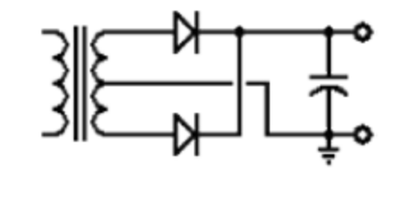
If we place a capacitor at the output of the full-wave rectifier as shown to the top, the
capacitor will charge to the peak voltage each half-cycle, and then will discharge more slowly through the load while the rectified voltage drops back to zero before beginning the next half cycle. Thus, the capacitor helps to fill in the gaps between the peaks, as shown in red in the first figure to the bottom.
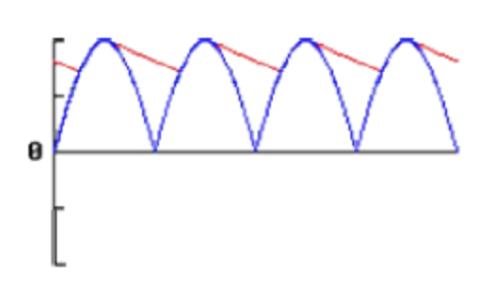
Although we have used straight lines for simplicity, the decay is actually the normal
exponential decay of any capacitor discharging through a load resistor. The extent to which the capacitor voltage drops depends on the capacitance of the capacitor and the amount of current drawn by the load; these two factors effectively form the RC time constant for voltage decay.

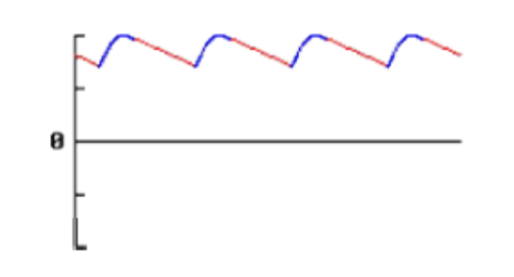
As a result, the actual voltage output from this combination never drops to zero, but
rather takes the shape shown in the second figure shown above.

REGULATOR
the output of most power supplies should be a constant voltage. Unfortunately, this is
difficult to achieve. There are two factors that can cause the output voltage to change.
• Change in AC Line Voltage
• Change in Load Resistance
First, the ac line voltage is not constant. The so-called 46 volts ac can vary from about 36
volts ac to 56 volts ac. This means that the peak ac voltage to which the rectifier responds can vary from about 40 volts to 50 volts. The ac line voltage alone can be responsible for nearly a 20 percent change in the dc output voltage.

The second factor that can change the dc output voltage is a change in the load resistance.
In complex electronic equipment, the load can change as circuits are switched in and out. In a television receiver, the load on a particular power supply may depend on the brightness of the screen, the control settings, or even the channel selected. These variations in load resistance tend to change the applied dc voltage because the power supply has a fixed internal resistance. If the load resistance decreases, the internal resistance of the power supply drops more voltage. This causes a decrease in the voltage across the load. Many circuits are designed to operate with a particular supply voltage. When the supply voltage changes, the operation of the circuit may be adversely affected. Consequently, some types of equipment must have power supplies that produce the same output voltage regardless of changes in the load resistance or changes in the ac line voltage. This constant output voltage may be achieved by adding a circuit called the voltage regulator at the output of the filter.There are many different types of regulators in use today.

IC VOLTAGE REGULATORS
A voltage regulator is a circuit that supplies a constant voltage regardless of changes in load currents. Although voltage regulators can be designed using op-amps, it is quicker and easy to use IC voltage regulators. Furthermore, IC voltage regulators are versatile and relatively inexpensive and are available with features such as a programmable output, current/voltage boosting, thermal shutdown and floating operation for high voltage applications. IC voltage regulators are of the following types

1. Fixed Output Voltage Regulators
a. Positive Voltage Regulators – IC 7800 Series
b. Negative Voltage Regulators – IC 7900 Series
2. Adjustable Output Voltage Regulators
a. Positive Voltage Regulators – IC LM317 Series
b. Negative Voltage Regulators – IC LM337 Series

Voltage regulators are commonly used for on-card regulation and laboratory-type power
supplies.
Typical performance parameters for voltage regulators are
• Line regulation
• Load regulation
• Temperature stability
• Ripple rejection

Line or input regulation is defined as the change in output voltage for a change in the
input voltage and is usually expressed in milli volts or as a percentage of output voltage.

Load regulation is the change in output voltage for a change in load current and is also
expressed in milli volts or as a percentage of output voltage.

Temperature stability or average temperature coefficient of output voltage is the change
in output voltage per unit change in temperature and is expressed in milli volts/ºC.

Ripple rejection is the measure of regulators ability to reject ripple voltages. It is usually
expressed in decibels.

The smaller the values of line regulation, load regulation, and temperature stability, the
better the regulator.

Fixed Voltage Regulators
Positive voltage regulator series with seven voltage options – IC 7800 Series

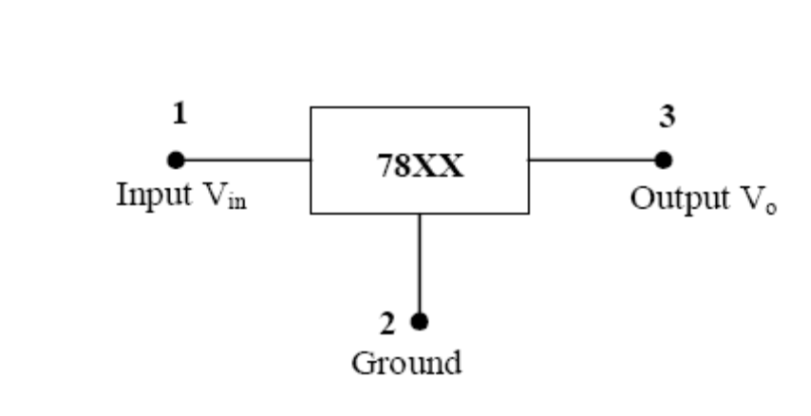
The 7800 series consists of three – terminal positive voltage regulators with seven
voltage options. The last two numbers “00” represents the output voltage of the regulator. These ICs are designed as fixed voltage regulators and with adequate heat sinking can deliver output currents in excess of 1A. These ICs also have internal thermal overload protection and internal short-circuit current limiting. As shown in figure, proper operation requires a common ground between input and output voltages. In addition, the difference between input and output voltages (Vin - Vo), called dropout voltage, must be typically 2.0 V.

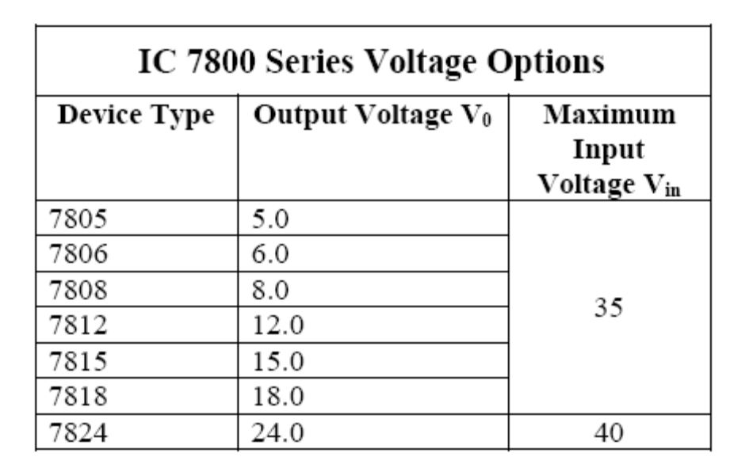

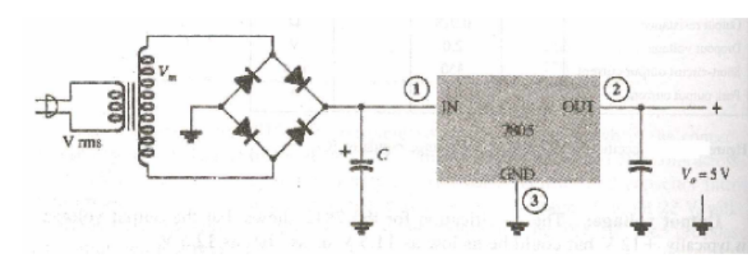
Functions of capacitors used at input and output sides:

The capacitor at the input side is used to filter the unregulated input voltage and is
connected to the IC’s IN terminal.
The capacitor at the output side is used to filter the regulated output voltage mostly for
any high-frequency noise.

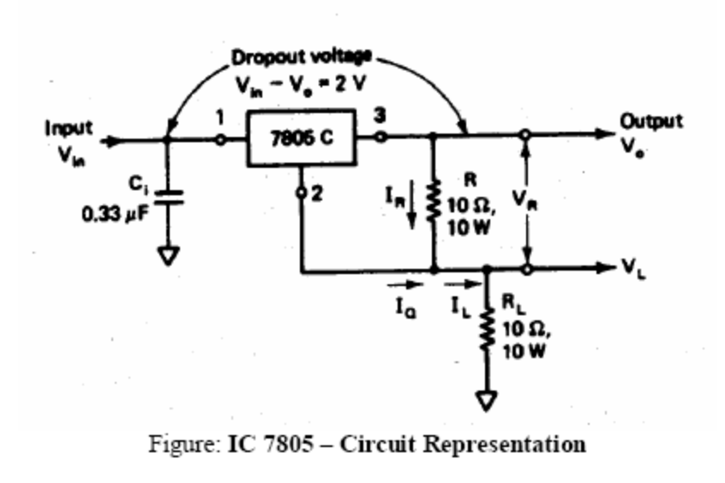
The output voltage Vo with respect to ground is
Vo = V_{R} + V_{L}
V_{R} = I_{R} * R and V_{L} = I_{L} * R_{L}
V_{in} = V₀ + V _{Dropout Voltage}
= V₀ + 2V

Negative Voltage Regulator series with Nine voltage options – IC 7900 Series
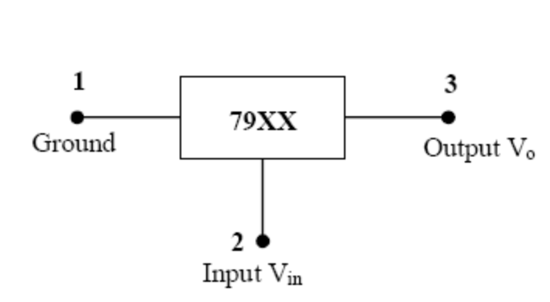
The IC 7900 series of fixed output negative voltage regulators are complements to the
7800 series devices. These negative regulators are available in the same seven voltage options as the 7800 devices. In addition two extra voltage options, -2V and -5.2V, are also available in the negative 7900 series.
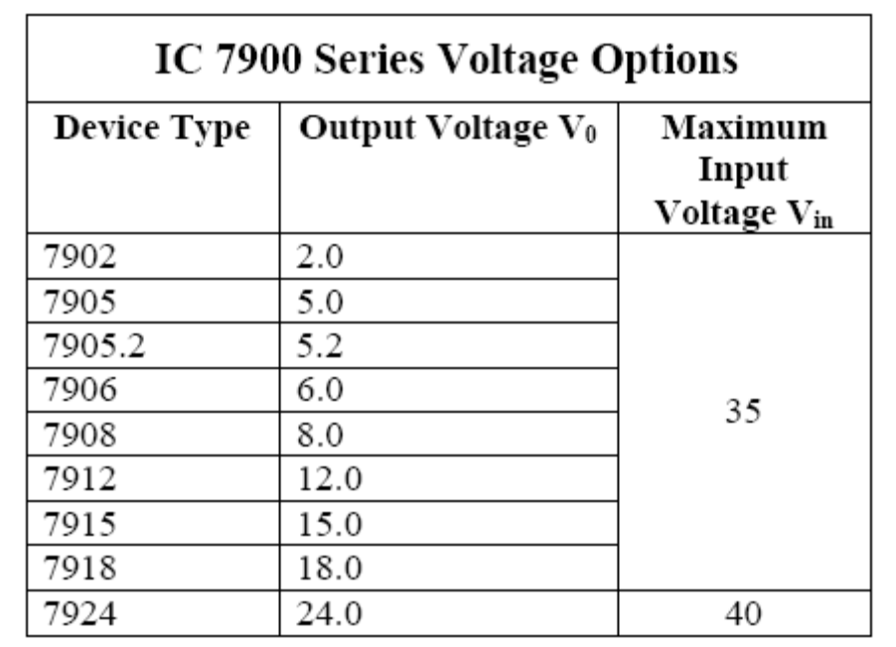

Adjustable Voltage Regulators
Adjustable voltage regulators satisfies many voltage requirements from 1.2V up to 57V. In addition they have the following performance and reliability advantages over the fixed types.
▪ Improved system performance by having line and load regulation of a factor of 10 or
better.
▪ Improved overload protection allows greater output current over operating temperature range.
▪ Improved system reliability with each device being subjected to 100% thermal limit burn
Thus, adjustable voltage regulators have become more popular because of versatility,
performance and reliability. The LM317 series is the most commonly used general purpose adjustable voltage regulator.
Adjustable Positive Voltage Regulators – LM317 Series
LM317 series are available with output voltage of 1.2V to 57V and output current from
0.1 to 1.5A. The three terminals of LM317 are V_{IN} , V_{OUT} and ADJUSTMENT(ADJ).

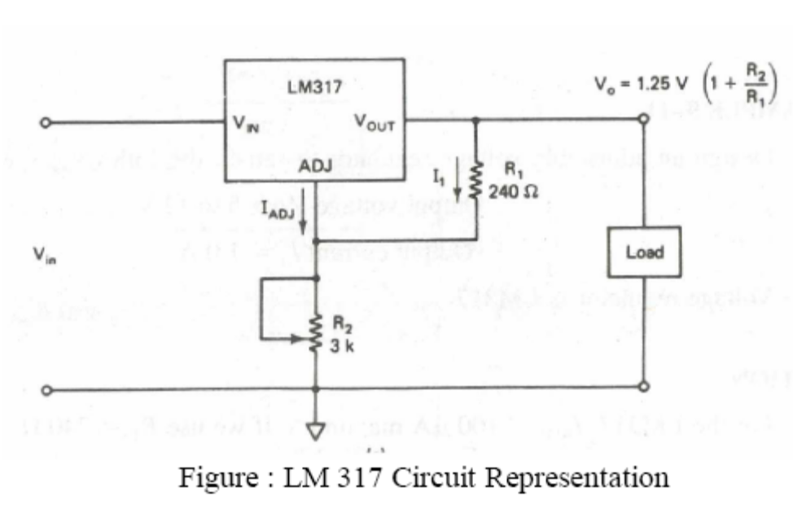
Above figure shows a typical connection diagram for the LM317 regulator. From this
diagram it is obvious that the LM317 requires only two external resistors to set the output
voltage. When configured as shown in the figure, the LM317 develops a nominal 1.25 voltage, referred to as the reference voltage V_{REF} , between the output and adjustment terminal.
When configured as shown in figure, the LM317 develops a nominal 1.25V, referred to
as the reference voltage V_{REF} , between the output and adjustment terminal. This reference voltage is impressed across resistor R1 and, since the voltage is constant, the current I₁ is also constant for a given value of R1. Because resistor R1 sets the current I1, it is called current set or program resistor. In addition to the current I1, the current IADJ from the adjustment terminal also flows through the output set resistor R2.

The LM317 is designed such that IADJ is very small and constant with line and load
changes. The maximum value of adjustment pin current IADJ is 100μA. Thus referring to the figure, the output voltage V0 is
V₀=R₁I₁ + R₂ (I₁+I_{ADJ}) …………………………(Eqn – 1)
Where I1 = V_{REF}/R1
R1 = Current (I1) set resistor
R2 = Output (V0) set resistor
I_{ADJ} = Adjustment pin current
Substituting the value of I₁ in equation – 1 and rearranging, we get
V0 = V_{REF}(1+R2/R1) + I_{ADJ}R₂
Where V_{REF} = 1.25V.
However, the current IADJ is very small (100μA) and constant. Therefore, the voltage
drop across R2 due to IADJ is very small and can be neglected. In short,
V0 = 1.25(1+R2/R1)
This equation indicates that the output voltage V0 is a function of R2 for a given value of
R1 and can be varied by adjusting the value of R2. The current set resistor R1 is usually 240Ω, and to achieve good load regulation it should be tied directly to the output of the regulator rather than near the load.

Light Emitting Diode (LED)
Optoelectronic devices either produce light or use light in their operation. The first
of these, the light-emitting diode (LED), was developed to replace the fragile, short-life
incandescent light bulbs used to indicate on/off conditions on panels. A light-emitting
diode is a diode which, when forward biased, produces visible light. The light may be red, green, or amber, depending upon the material used to make the diode. Figure shows an LED and its schematic symbol. The LED is designated by a standard diode symbol with two arrows pointing away from the cathode. The arrows indicate light leaving the diode. The circuit symbols for all optoelectronic devices have arrows pointing either toward them, if they use light, or away from them, if they produce light. The LED operating voltage is small, about 1.6 volts forward bias and generally about 10 mill amperes. The life expectancy of the LED is very long, over
100,000 hours of operation.
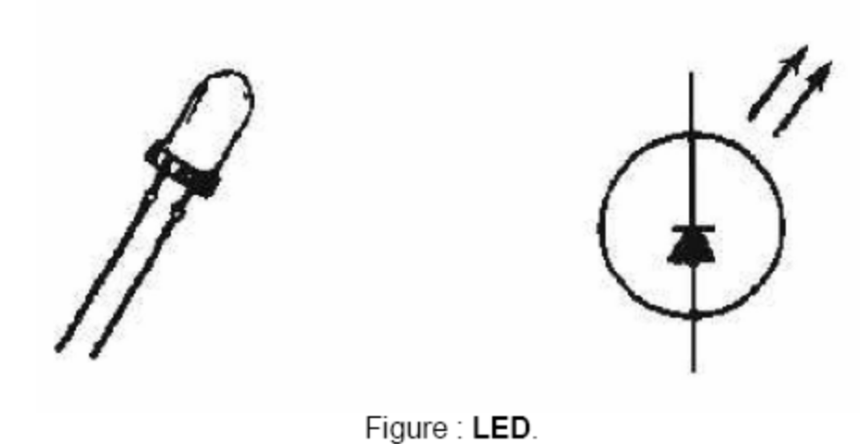

The atomic structure of the LED is carefully designed so that as free electrons cross the
junction from the N-type side to the P-type side, the amount of energy each electron releases as it drops into a nearby hole corresponds to the energy of a photon of some particular color. Therefore, that photon is released as a visible photon of that color.
Gallium Arsenide (GaAs) crystal has the interesting property of radiating significant
amounts of infrared radiation from the junction. By adding Phosphorus to the equation, they shortened the wavelength of the emitted radiation until it became visible red light. Further refinements have given yellow and green LEDs. More recently, blue LEDs have been produced, by putting nitrogen into the crystal structure. This makes full-color flat-screen LED displays possible.

LEDs are used widely as "power on" indicators of current and as displays for pocket
calculators, digital voltmeters, frequency counters, etc. For use in calculators and similar devices, LEDs are typically placed together in seven-segment displays.

LCD

A liquid crystal display (LCD) is a thin, flat display device made up of any number of
color or monochrome pixels arrayed in front of a light source or reflector. It is prized by
engineers because it uses very small amounts of electric power, and is therefore suitable for use in battery-powered electronic devices.

Each pixel (picture element) consists of a column of liquid crystal molecules
suspended between two transparent electrodes, and two polarizing filters, the axes of polarity of which are perpendicular to each other. Without the liquid crystals between them, light passing through one would be blocked by the other. The liquid crystal twists the polarization of light entering one filter to allow it to pass through the other.

The molecules of the liquid crystal have electric charges on them. By applying small
electrical charges to transparent electrodes over each pixel or sub pixel, the molecules are
twisted by electrostatic forces. This changes the twist of the light passing through the
molecules, and allows varying degrees of light to pass (or not pass) through the polarizing filters.

Before applying an electrical charge, the liquid crystal molecules are in a relaxed
state. Charges on the molecules cause these molecules to align themselves in a helical
structure, or twist (the "crystal"). In some LCDs, the electrode may have a chemical surface that seeds the crystal, so it crystallizes at the needed angle. Light passing through one filter is rotated as it passes through the liquid crystal, allowing it to pass through the second polarized filter. A small amount of light is absorbed by the polarizing filters, but otherwise the entire assembly is transparent.

When an electrical charge is applied to the electrodes, the molecules of the liquid
crystal align themselves parallel to the electric field, thus limiting the rotation of entering
light. If the liquid crystals are completely untwisted, light passing through them will be
polarized perpendicular to the second filter, and thus be completely blocked. The pixel will appear unlit. By controlling the twist of the liquid crystals in each pixel, light can be allowed to pass though in varying amounts, correspondingly illuminating the pixel.

Many LCDs are driven to darkness by an alternating current, which disrupts the
twisting effect, and become light or transparent when no current is applied.

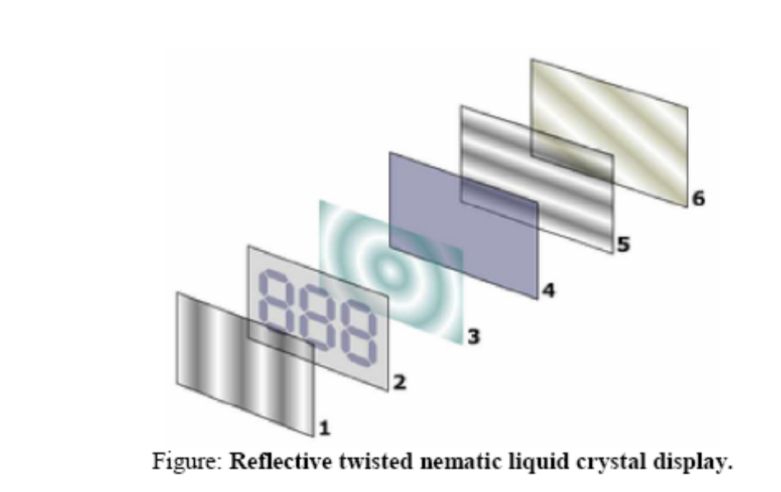
1. Vertical filter film to polarize the light as it enters.
2. Glass substrate with ITO electrodes. The shapes of these electrodes will determine the
dark shapes that will appear when the LCD is turned on. Vertical ridges are etched on
the surface so the liquid crystals are in line with the polarized light.
3. Twisted nematic liquid crystals.
4. Glass substrate with common electrode film (ITO) with horizontal ridges to line up
with the horizontal filter.
5. Horizontal filter film to block/allow through light.
6. Reflective surface to send light back to viewer.

Photodiode
Another special optoelectronic device in common use today is the photodiode. Unlike
the LED, which produces light, the photodiode uses light to accomplish special circuit
functions. Basically, the PHOTODIODE is a light-controlled variable resistor. In total
darkness, it has a relatively high resistance and therefore conducts little current. However, when the PN junction is exposed to an external light source, internal resistance decreases and current flow increases. The photodiode is operated with reverse-bias and conducts current in direct proportion to the intensity of the light source.

Figure given below shows a photodiode with its schematic symbol. The arrows
pointing toward the symbol indicate that light is required for operation of the device. A light source is aimed at the photodiode through a transparent "window" placed over the
semiconductor chip. Switching the light source on or off changes the conduction level of the photodiode. Varying the light intensity controls the amount of conduction. Because
photodiodes respond quickly to changes in light intensity, they are extremely useful in digital applications such as computer card readers, paper tape readers, and photographic light meters. They are also used in some types of optical scanning equipment.
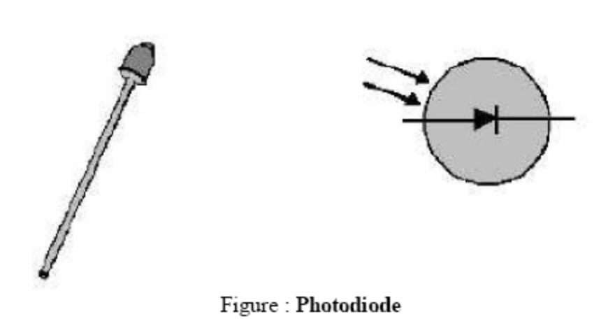

Photo Transistor
A second optoelectronic device that conducts current when exposed to light is the
phototransistor. A phototransistor, however, is much more sensitive to light and
produces more output current for a given light intensity that does a photodiode. Figure given below shows one type of phototransistor, which is made by placing a photodiode in the base circuit of an NPN transistor. Light falling on the photodiode changes the base current of the transistor, causing the collector current to be amplified. Phototransistors may also be of the PNP type, with the photodiode placed in the base-collector circuit.
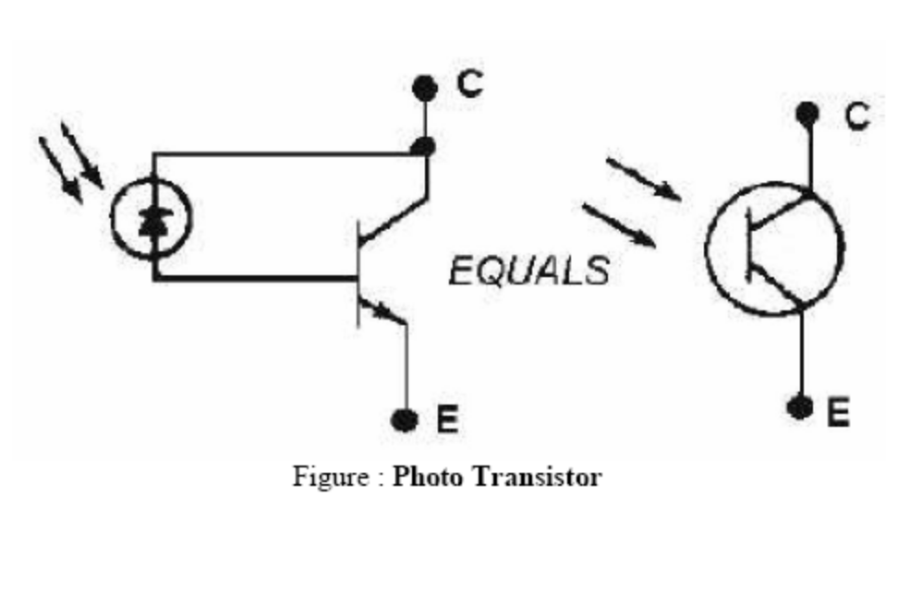
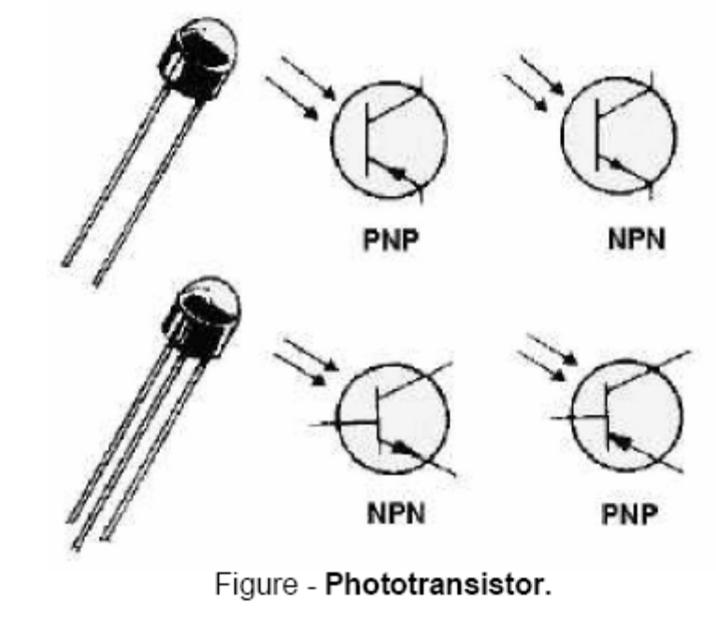
Figure shown below illustrates the schematic symbols for the various types of
phototransistors. Phototransistors may be of the two-terminal type, in which the light intensity on the photodiode alone determines the amount of conduction. They may also be of the three terminal type, which have an added base lead that allows an electrical bias to be applied to the base. The bias allows an optimum transistor conduction level, and thus compensates for ambient (normal room) light intensity.

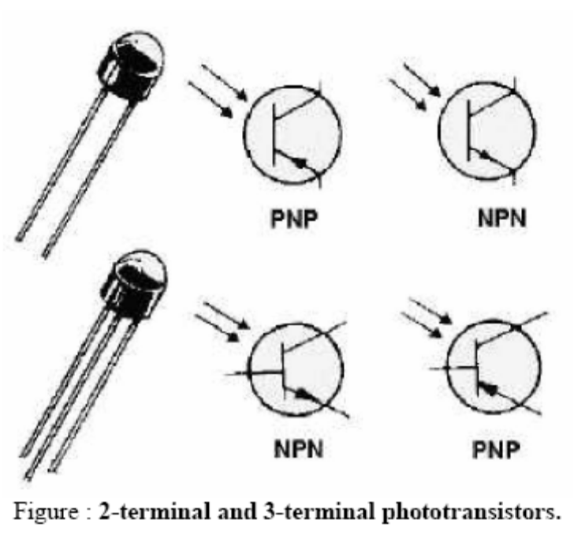

Opto Coupler

When it is necessary to block the voltage between one electronic circuit and another, and
transfer the signal at the same time, an amplifier coupling capacitor is often used as shown in figure given below. Although this method of coupling does block dc between the circuits, voltage isolation is not complete.

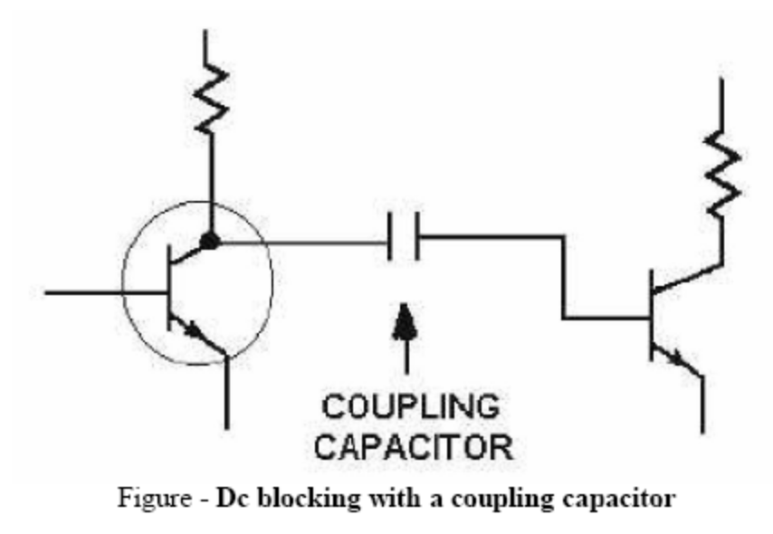
A newer method, making use of optoelectronic devices to achieve electrical isolation, is
the optical coupler, shown in figure given below. The coupler is composed of an LED and a photodiode contained in a light-conducting medium. As the polarity signs in figure show, the LED is forward biased, while the photodiode is reverse biased. When the input signal causes current through the LED to increase, the light produce by the LED increases. This increased light intensity causes current flow through the photodiode to increase. In this way, changes in input current produce proportional changes in the output, even though the two circuits are electrically isolated.
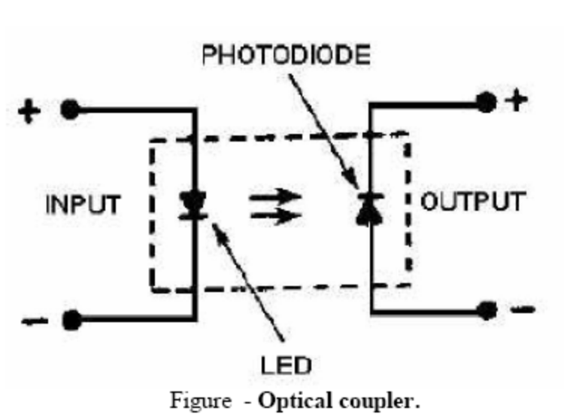
The optical coupler is suitable for frequencies in the low megahertz range. The
photodiode type shown above can handle only small currents; however, other types of couplers, combining phototransistors with the SCR, can be used where more output is required. Optical couplers are replacing transformers in low-voltage and low-current applications. Sensitive digital circuits can use the coupler to control large current and voltages with low-voltage logic levels.

SEVEN SEGMENT DISPLAY
The illustration given below shows the basic layout of the segments in a seven-segment
display. The segments themselves are identified with lower-case letters "a" through "g," with segment "a" at the top and then counting clockwise. Segment "g" is the center bar.
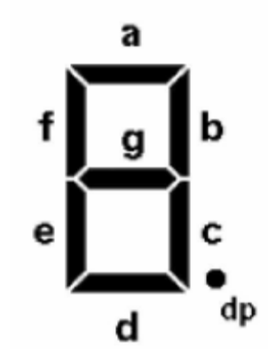
Most seven-segment digits also include a decimal point ("dp"), and some also include an
extra triangle to turn the decimal point into a comma. This improves readability of large numbers on a calculator, for example. The decimal point is shown here on the right, but some display units put it on the left, or have a decimal point on each side.
Seven-segment displays can be constructed using different technologies. The three most common methods are
1. fluorescent displays (used in many line-powered devices such as microwave ovens and
some clocks and clock radios)
2. liquid crystal displays (used in many battery-powered devices such as watches and many digital instruments)and
3. LEDs (used in either line-powered or battery-powered devices).

Schematic Diagram of LED based System
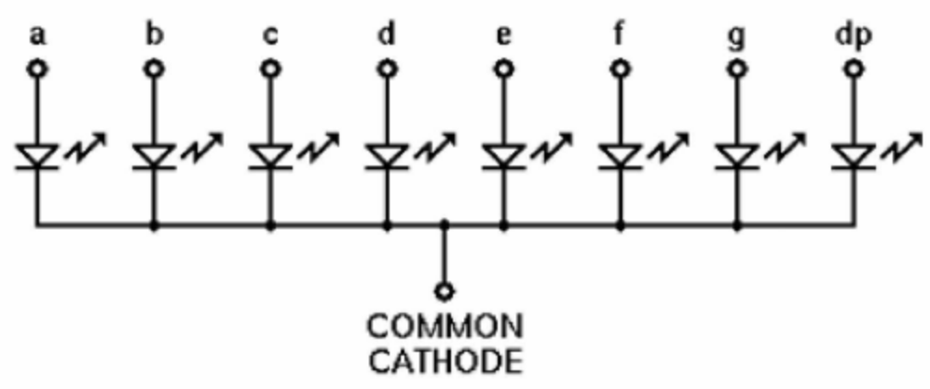
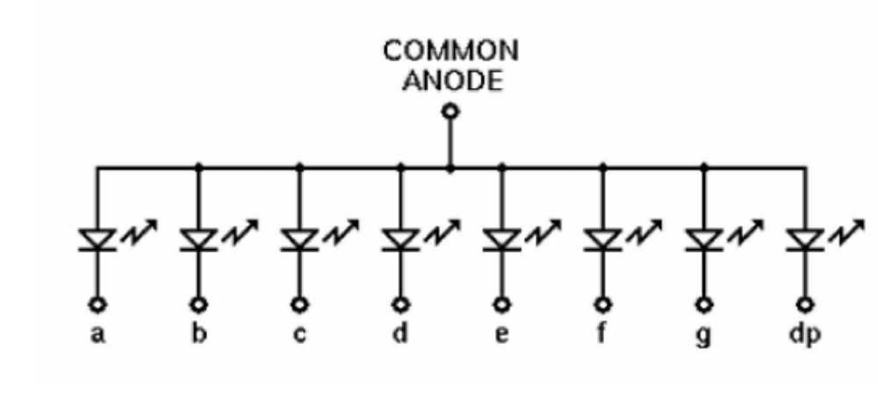
As shown in the two schematic diagrams above, the LEDs in a seven-segment display are
not isolated from each other. Rather, either all of the cathodes, or all of the anodes, are connected together into a common lead, while the other end of each LED is individually available. This means fewer electrical connections to the package, and also allows us to easily enable or disable a particular digit by controlling the common lead. There is no advantage of the common-cathode seven-segment unit over the common-anode version, or vice-versa. Each type lends itself to certain applications, configurations, and logic families.
SILICON CONTROLLED RECTIFIER (SCR)
The silicon controlled rectifier, usually referred to as an SCR, is one of the
families of semiconductors that include transistors and diodes. A drawing of an SCR and its schematic representation is shown in views A and B of figure given below. Not all SCRs use the casing shown, but this is typical of most of the high-power units.

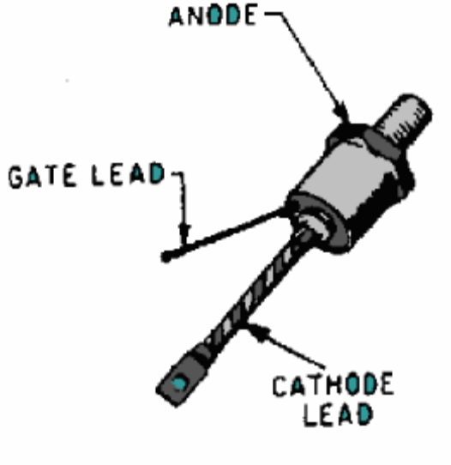

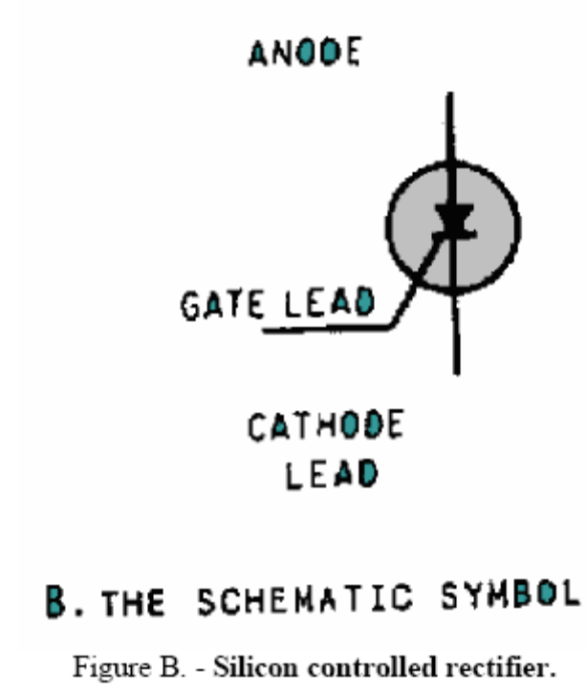
Although it is not the same as a diode or a transistor, the SCR combines features of both The basic purpose of the SCR is to function as a switch that can turn on or off small or large amounts of power. It performs this function with no moving parts that wear out and no points that require replacing. There can be a tremendous power gain in the SCR; in some units a very small triggering current is able to switch several hundred amperes without exceeding its rated abilities.
The SCR is an extremely fast switch. It is difficult to cycle a mechanical switch several hundred times a minute; yet, some SCRs can be switched 25,000 times a second. It takes just microseconds (millionths of a second) to turn on or off these units. Varying the time that a switch is on as compared to the time that it is off regulates the amount of power flowing through the switch. Since most devices can operate on pulses of power (alternating current is a special form of alternating positive and negative pulse), the SCR can be used readily in control applications.
Motor-speed controllers, inverters, remote switching units, controlled rectifiers, circuit overload protectors, latching relays, and computer logic circuits all use the SCR.
The SCR is made up of four layers of semiconductor material arranged PNPN. The construction is shown in view figure A. In function, the SCR has much in common with a diode, but the theory of operation of the SCR is best explained in terms of transistors.

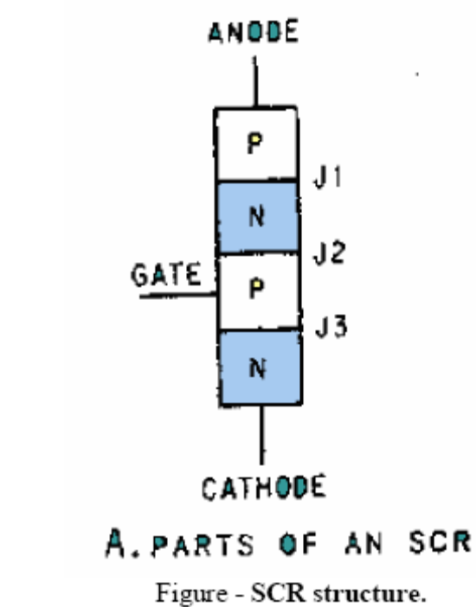
The rectifier circuit (anode-cathode) has a low forward resistance and a high reverse
resistance. It is controlled from an off state (high resistance) to the on state (low resistance) by a signal applied to the third terminal, the gate. Once it is turned on it remains on even after removal of the gate signal, as long as a minimum current, the holding current I_{h}, is maintained in the main or rectifier circuit. To turn off an SCR the anode-cathode current must be reduced to less than the holding current, Ih. The characteristic curve is as shown below.
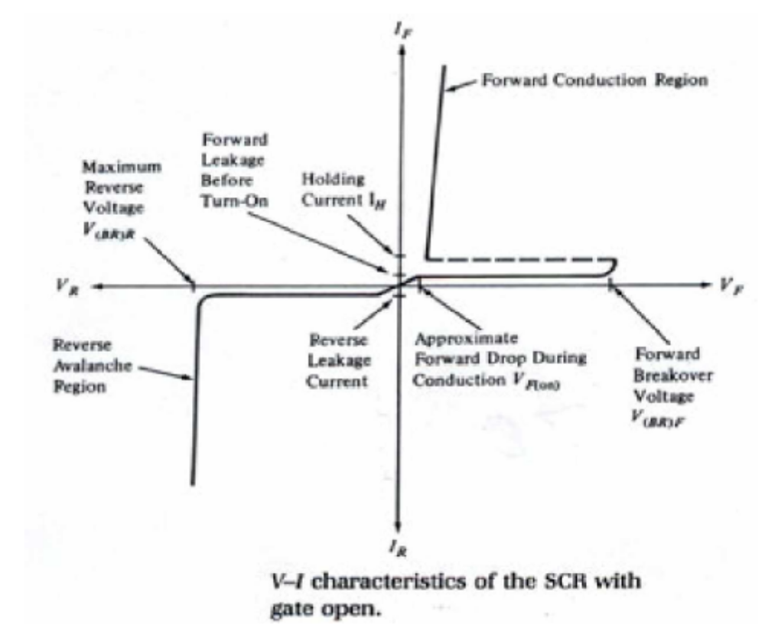

Notice the reverse characteristics are the same as discussed previously for the rectifier or
diode, having a break over voltage with its attending avalanche current; and a leakage current for voltages less than the break over voltage. However, in the forward direction with open gate, the SCR remains essentially in an off condition (notice though that there is a small forward leakage) until the forward break over voltage is reached. At that point the curve snaps back to a typical forward rectifier characteristic. The application of a small forward gate voltage switches the SCR onto its standard diode forward characteristic for voltages less than the forward break over voltage.
Obviously, the SCR can also be switched by exceeding the forward break over voltage,
however this is usually considered a design limitation and switching is normally controlled with a gate voltage. One serious limitation of the SCR is the rate of rise of voltage with respect to time, dV/dt. A large rate of rise of circuit voltage can trigger an SCR into conduction. This is a circuit design concern. Most SCR applications are in power switching, phase control, chopper, and inverter circuits.
THE UNIJUNCTION TRANSISTOR
One of the oddest semiconductor devices in use is the unijunction transistor (UJT). As its
name suggests, this is a three-terminal device, which nevertheless has only one PN junction. It cannot amplify an applied signal, but it nevertheless can be used as the active element in an oscillator circuit.
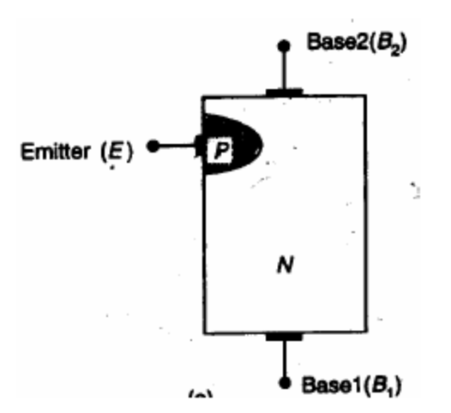

Above figure shows the physical construction of a typical UJT. It consists of a bar of N-type silicon with electrical connections at either end, plus an aluminum wire bonded to a point along the length of the silicon bar. At the bonding point, the aluminum creates a P-type region in the silicon bar, thus forming a PN junction.
Because there's only one junction, it's not reasonable to use the terms anode or cathode, so designations are taken instead from transistor notations. The P-type connection is known as the "Emitter," while the two N-type connections are designated "Base 1" and "Base 2." For this reason, the device is sometimes called a "double-base diode."
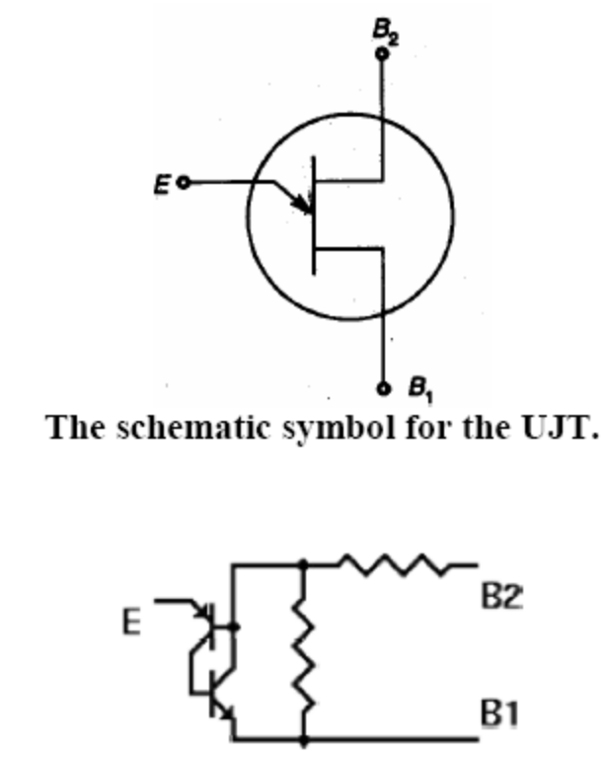
In use, an appropriate bias voltage is applied between the two bases, with B2 made positive with respect to B1. Because the N-type bar is resistive, a relatively small current will flow through it, and the applied voltage will be distributed evenly along its length. If we start with the Emitter grounded, the junction will be reverse biased and there will be no emitter current. As the emitter voltage increases, there is no change until the junction suddenly becomes forward biased.
At this point, the emitter injects holes into the silicon bar, greatly reducing the effective
resistance of the bar between E and B1. This will lower the emitter voltage required to keep the junction forward biased, and will sustain a heavy emitter current. This condition will continue as long as the circuit connected to the emitter can sustain the heavier current flow. The UJT thus behaves like a variation of the SCR, as suggested by the equivalent circuit shown to the right.
The unijunction transistor (UJT) is a three terminal device with characteristics very different from the conventional 2 junction, bipolar transistor. It is a pulse generator with the trigger or control signal applied at the emitter. This trigger voltage is a fraction (n) of interbase voltage; V_{bb}.The UJT circuit symbol, junction schematic, and characteristic curve are shown below.

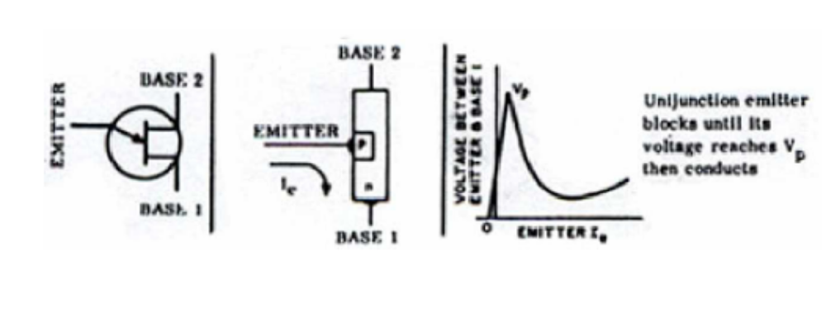
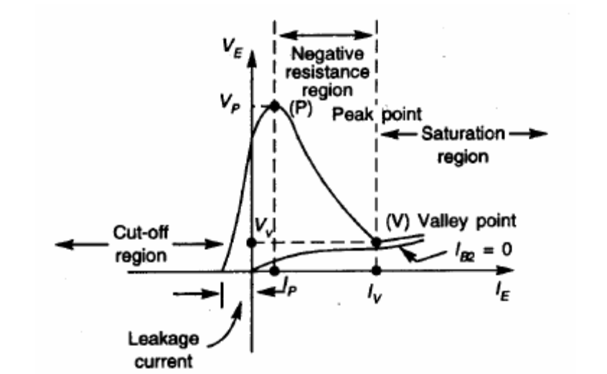
The emitter terminal does not inject current into the base region until its voltage reaches Vp. Once Vp is reached the base circuit conducts and a positive pulse appears at the B1 terminal and a negative pulse at B2. The UJT incorporates a negative resistance region, a low emitter current, and a high output pulse current at terminals B1 and B2, making it an ideal pulse trigger. A simple RC timer circuit using a UJT is shown below.

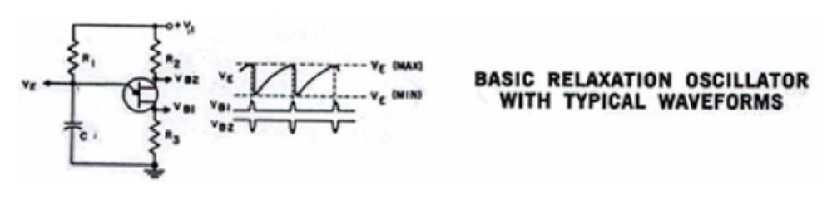
The very basic specifications of a UJT are:
(a) V_{bb}(max) - The maximum interbase voltage that can be applied to the UJT
(b) R_{bb}-the interbase resistance of the UJT
(c) n - The intrinsic standoff ratio which defines Vp.
(d) I_{p} - The peak point emitter current

DIAC
The diagram given below shows a five-layer device, which is known as a diac. The diac
is a bidirectional trigger diode which is designed specifically to trigger a triac or SCR.

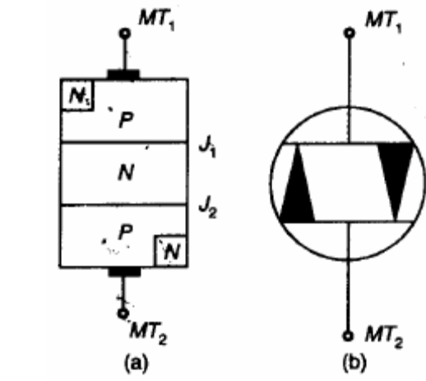
At first glance, it seems unreasonable or even impossible, considering that each
connection to the semiconductor crystal overlaps a pn junction. However, the device does work, and indeed works well. The terms anode and cathode no longer apply, so the connections are simply named terminal 1 (T1) and terminal 2 (T2). Each terminal can serve as either anode or cathode, according to the polarity of the applied voltage.
That same applied polarity also determines which of the end junctions is active, and
which one is bypassed. Thus, if T1 is positive with respect to T2, T1's N-type region is ignored (electrons are pulled away from that junction) and its P-type region serves as the anode. At the same time, the relative negative voltage at T2 pulls holes from the P-type region towards the terminal (removing them from the next junction), but tends to push electrons from its N-type region across that junction into the P-type region, thus making them available for conduction. The diac, like the four-layer diode, remains non-conducting until its break over voltage is reached, at which point it turns on fully and remains on until the applied voltage or circuit current are reduced below the holding values at which conduction can be maintained. Since the diac is normally used in ac circuits, operating as part of the control circuit for devices powered from a household wall socket or similar source, this is not a problem. In such applications, the diac is triggered each half-cycle of ac power, and then turns off at the end of the half-cycle when the line voltage reverses polarity.

Basically the diac does not conduct (except for a small leakage current) until the
break over voltage is reached. At that point the diac goes into avalanche conduction also at that point the device exhibits a negative resistance characteristic, and the voltage drop across the diac snaps back, typically about 5 volts, creating a breakover current sufficient to trigger a triac or SCR. A typical characteristic is shown below with its schematic symbol:

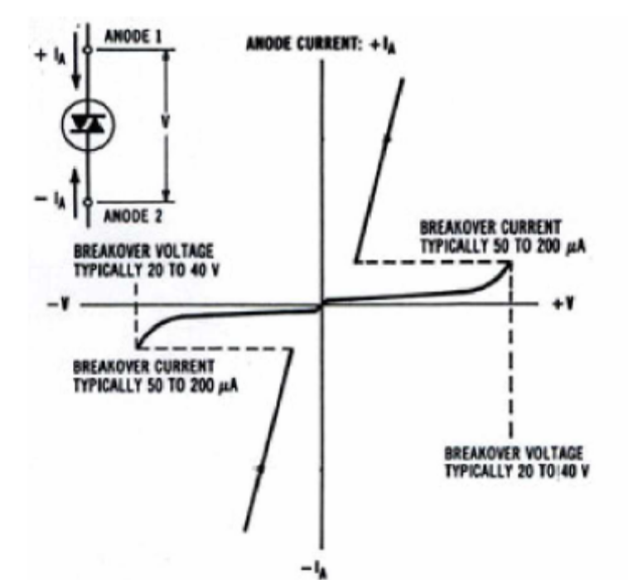
Although most diacs have symmetric switching voltages,asymmetric diacs are available.
Typical diacs have a power dissipations ranging from 1/2 to 1 watt.
The main characteristics are:
(a) Breakover voltage
(b)Voltage symmetry
(c) Breakback voltage
(d) Breakover current
(d) Power dissipation
TRIAC
The triac is a three terminal semiconductor for controlling current in either direction.
Below is the schematic symbol for the triac. Notice the symbol looks like two SCRs in parallel (opposite direction) with one trigger or gate terminal. The main or power terminals are designated as MT1 and MT2. (See the schematic representation below) When the voltage on the MT2 is positive with regard to MT1 and a positive gate voltage is applied, the left SCR conducts. When the voltage is reversed and a negative voltage is applied to the gate, the right SCR conducts. Minimum holding current, Ih, must be maintained in order to keep a triac conducting.

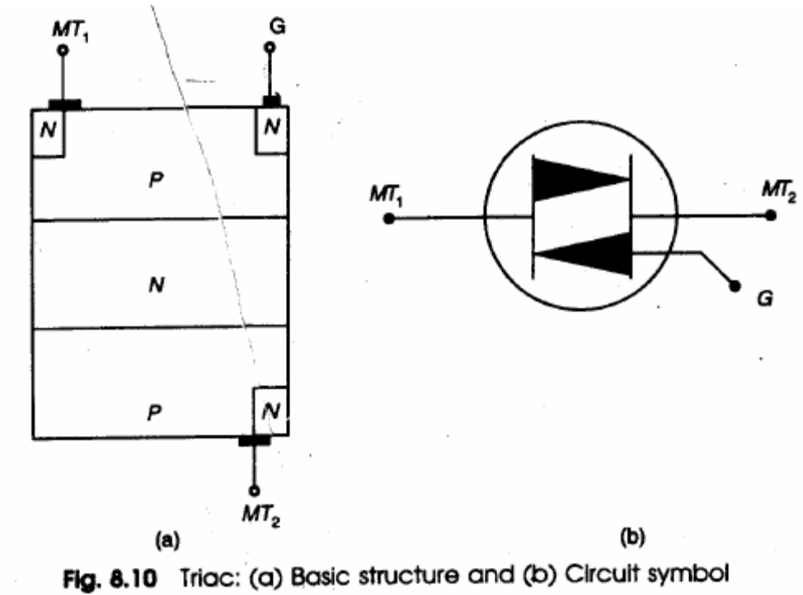

A triac operates in the same way as the SCR however it operates in both a forward and
reverse direction. To get a quick understanding of its operation refer to its characteristic curve below and compare this to the SCR characteristic curve. It can be triggered into conduction by either a plus (+) or minus (-) gate signal.

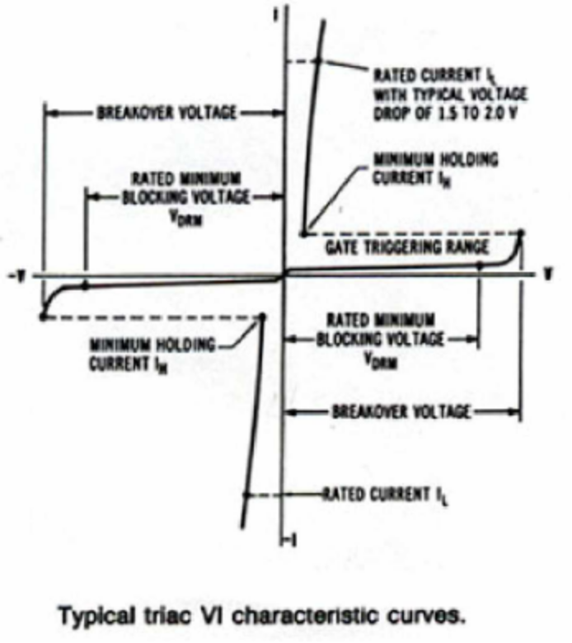
Obviously a triac can also be triggered by exceeding the break over voltage. This is not
normally employed in triac operation. The break over voltage is usually considered a design limitation. One other major limitation, as with the SCR, is dV/dt, which is the rate of rise of voltage with respect to time. A triac can be switched into conduction by a large dV/dt. Typical applications are in phase control, inverter design, AC switching, relay replacement etc.

Major considerations when specifying a triac are:
(a) Forward and reverse break over voltage.
(b)Maximum current
(c) Minimum holding current
(d) Gate voltage and gate current trigger requirements.
(e) Switching speed
(f) Maximum dV/dt

